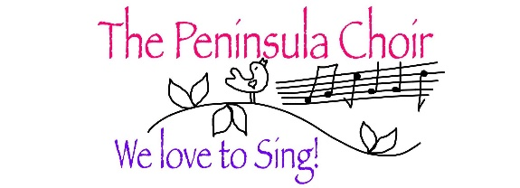

Annual Report for The Peninsula Choir 2022-23

This has been a difficult year in a few ways, but in spite of them we ended the year on a happy note, with optimism for our future.

In terms of Membership, our numbers are very low, currently just 20, fortunately divided fairly equally between the parts, but the quality of singing with this small group is still beautiful, as evidenced by our end-of-year Concert, where the group numbered a mere 16, but nothing was lost in terms of volume and sweetness. We will have an Open Evening on September 12th 2023 and hope to recruit a few more ladies of the calibre we welcomed in our last intake of new ladies.

We began the year still practising in the Community Centre in Portavogie, but began to feel very homesick and after our mid-term break we joyfully returned 'home' to Maxwell's, - which unfortunately cost us the loss of one member. We settled in immediately as if never being away, and have a new, very amenable caretaker too.

During October, Emma went on Maternity leave, but found us a replacement pianist, Stuart Tanner, pianist to the Donaghadee Male Voice Choir. He is
extremely capable and we were grateful to have had such a smooth handover.
Emma joined us again during the next term.

We only had one event at Christmas, which was our usual contribution to the Christmas Lights switch-on in Maxwells. Our first outing for some considerable time! Then the Christmas break over, we headed into the winter months with many absences, due mostly to illnesses, of which there seemed an unusual number this year. Consequently, we abandoned any thoughts of participating in the Bangor Choral Festival this year, but are still determined to enter this coming year, if at all possible. Then we put all our efforts into working up the song-list for our Summer Concert.

The final event of the year then, was the Concert, which we held in Greyabbey, courtesy of Trinity Presbyterian Church. A huge Thank You must go to Jeanie who was our liaison person, and as well as getting all the practical help organised, had to wade through and fill out a long and annoyingly complicated Health and Safety Assessment. In addition, she introduced us to Jamie Brown, who had once performed with us in Portico, and now has a beautiful voice. He was the extra act half-way through, and there were a few damp eyes… The evening went very smoothly, with wonderful support from the Church community. Our Choir sang beautifully, and we're so very glad we won't have to sing those songs again for a while!! But all thanks to Christine for smuggling in The Frog Chorus to add to our programme. The small audience was very appreciative, and the whole evening was warm and friendly. And finally, we ended our year with a supper evening in The Saltwater Brig. So nice to just sit and chat with each other for a change.

Seedswap was held at Bishop's Mill again in May. Another very enjoyable event, which raised a very good sum this year, in spite of not having a huge number of visitors.

This year Barrhall Care Home asked if we would consider going there on a regular basis. But rather than concentrating on just Barrhall, Christine has organised a willing group of Choir members to visit other Care homes in our area. We also put together 2 sets of songs, one for Christmas and one of Golden Oldles. The following places were visited: Barrhall, Scrabo House in Newtownards, Mount Alexander in Comber, and Rocky Acres and Green Isle both in Portavogie. It has been a great success, much appreciated by the Care Homes.

I would like to thank our wonderful Committee, for once again helping Choir to steer it's way through this past year. It is great to be able to work constructively together, and bring all our various abilities to the group.

And of course, a huge Thank You for all our Choir members for getting through this year, in spite of everything, with continued faith in our group, united by our love and joy in our singing.

Bee Kupicha
Choir Leader
September 2023

