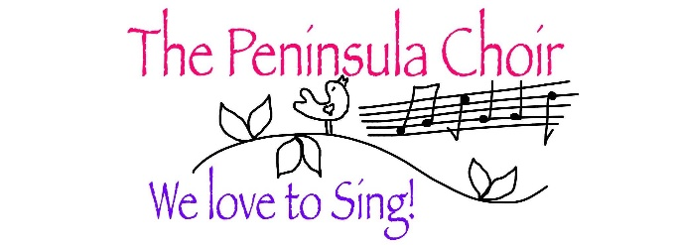

Annual Report 2021 - 2022

Our first term began with us rehearsing in Greyabbey Presbyterian Church who had very kindly opened their doors to us, as Maxwell’s was too small to allow for proper distancing. But we were very depleted in number, mostly because of Covid, it was a difficult space to sing in, and to complicate matters, I had to step back from Choir to care for my partner. Fortunately, Emma took over with her usual confidence, and kept everything together, but by Christmas it was clear that the venue was too unsympathetic to sing in, so in January we moved to the Community Centre in Portavogie, and this has been a great success. It is more central for most Choir members, and we have a very safe space to store all our equipment, with the bonus of a cheery, helpful caretaker.
However, over the year quite a few members had, for various reasons, decided to leave Choir, and it left us struggling to fill the parts some evenings, due mainly to Covid absences. Accordingly, we decided to have 2 Open Evenings at the end of May. We had already attracted a couple of new Members during the year, but these 2 evenings were very well attended, and we now have 9 more Members than we started the year with. We hope most of them will stay and I took the opportunity of addressing new Members, to impress on everyone the ongoing importance of commitment to the Choir, specifically in regular attendance, so that we can rebuild that sense of group endeavour which has been one of our core strengths.
Due to ongoing restrictions, we have only had one outing this year. But at the beginning of June Barrhall Care Home asked us to come and sing. They were eager to open the Home up more, as Covid restrictions became more relaxed and we had a wonderful afternoon singing golden oldies with the Residents. It felt so good to be doing something purposeful again with our singing.
Seedswap also returned this year, hosted by Bubsy at Bishop’s Mill, on a beautiful day in May, and we had a very enjoyable few hours in warm sunshine there, with delicious refreshments, surrounded by a splendid collection of plants, and all went home happy with their swaps. This is another regular event that we missed so much last year, and holding it in May rather than March, seemed a better idea too, as it was warm enough to sit outside.

This year, Emma married Eoin and they are expecting a child in October. We wish them all joy in their future. Fortunately, Emma has found us an extremely competent pianist who will work with us during her maternity leave, and we are truly grateful for that.
And now we can look forward to the coming year with optimism! Reading last year’s Report gave me such a feeling of bleakness because of Covid and all the restrictions, but things feel quite different now, especially since Christmas, when it felt like a new beginning. We have a good rehearsal space, and an expanded Membership, which I hope will become a close group, dedicated to the best we can do. We intend to enter the Bangor International Choral Festival in April, and some of us may pay a visit to the Derry Festival, which perhaps we will feel confident enough to enter next year! And we hope to have our own concert, at last, as well as taking part in community events as in previous years.
Finally, as ever, I want to say thank you to our faithful Committee, particularly to Deirdre, who took over being Treasurer from Christine. Christine had been our Treasurer for 8 years, and was, I believe, despairing of ever handing on the responsibility! But all members of the Committee work hard behind the scenes, not just at Meetings, and it is a pleasure to be able to organise our affairs together with such a solid group, with a multitude of aptitudes to bring to our work.
It continues to be a joy and privilege for me to be a part of this, our endeavour – the magic which is the creation of beautiful music.

Signed: [Bee Kupicha]

Date: 6 September 2002

