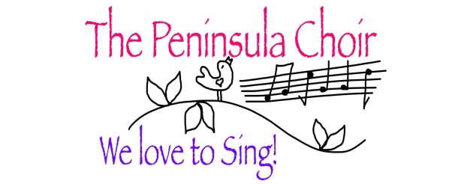
Annual Report 2019-2020
This has surely been the strangest year in anyone’s memory, when in the blink of an eye it became impossible for us, and many other musical groups, to be together in any meaningful way. Thus was cut short what had, until then, been a busy and fruitful programme of activity for our Choir. We had great plans for our future and were considering how to celebrate our 10th Anniversary in October, and maybe taking part in the Derry Choral Festival. With our Gift money we had bought a set of microphones and a mixing desk for ourselves, rather than having to rely on Paddy Craig every time we give a performance, and we also had a sturdy sandwich-board made with our logo ‘in large’ glued to it, so that we could advertise outside a concert or other activity nearby.

We began the year with an October concert in the Church Hall of Millisle and Ballycopeland Presbyterian Church. This was instead of our Midsummer concert, when we could not find a date to suit everyone, so the congregation welcomed us to their Hall, and we gave them a great evening of ‘Songs from the Movies’. Our Special Guest was Steven Irwin, baritone, who sang some wonderfully entertaining Cole Porter numbers, which included a duet with Cheryl Williams!! Our alto ‘small group’, sang a bluesy little song, á capella, and Carolyn Sachno sang solo for one of our songs, so lots of variety this year. Each table was decorated with a theme from one of the songs, and a prize was awarded to the best dressed table by an impartial judge from the audience. The Hall was absolutely packed, and as usual the ‘dinner’ was varied and delicious –many thanks to all of you who brought food, and to those who cleared up afterwards.

We were determined to do something in Portico again this year in December, and invited Donaghadee Ladies’ Choir, and the Amici Choir from Cloughey to join us in an evening of Christmas music. Again, a packed venue and wonderful evening, and it was so good to hear other Choirs with their very varied offerings on the Christmas theme. Emma Morgan (our pianist) is also Musical Director for Donaghadee Ladies, so was extremely busy all evening, but she accomplished all her roles with smooth ease.

We also managed to squeeze in a third Concert in February, at the request of Ballyphilip Church of Ireland, Portaferry. This was a fund-raiser for rewiring of the church buildings and we were delighted to perform ‘Songs from the Movies’ all over again, with Steven Irwin, but not drums or guitar. It was a warm and cheerful evening and raised a very respectable amount, with donations, for Ballyphilip. Deirdre brought along a box of corsages, which we had decided to buy as a way to jolly up our black Concert-wear. And they certainly did!! This was also the first time we used the microphones and mixing desk, and I wasn’t sure I could get it all to work, but very fortunately, Rev. Gill Withers (of Ballyphilip) is au fait with such things and got the whole thing organised, and worked the mixer during the show. I was so grateful!!

As usual in the Autumn term, we had an Open Evening, and it is always good to have people come and check us out, but we did not manage to hold on to anyone for long, and we are still in need of a few new 1st Sopranos. But our membership remains constant. People who regularly come to our Concerts, compliment us every year on continued progress in terms of quality of tone and diction, but people also notice how absolutely focussed the Choir is in its tightness of delivery and group awareness. This was particularly the case in our last Concert for Ballyphilip and no wonder, as we had started learning this repertoire the previous Spring. If only we could always be so well rehearsed and confident. There is always room for progress. We decided to defer our entry for the Derry Festival till the following year, but it says much that we can feel equal to taking part in such a big event as this.

Our preparations for our Christmas repertoire included a few new pieces, one of them by Benjamin Britten from ‘A Ceremony of Carols’. Britten can really divide opinion, but I was so pleased with the progress we made with this, although some way still to go. Our visits to the Ard Cuan and Barrhall care homes went off well, although there were fewer of us this year, but it is always a pleasure, and maybe fewer is better? We rounded off the year with our annual singing in Kircubbin for the Lights Switch-on.

For our end of term get-together we hired Katch 22, Kircubbin, for the evening and had a really good meal and lots of laughter and singing to end the year, whilst looking forward to starting work on our next show, which will be ‘Songs from the Sixties’: sadly, sometime in the future, now.

In the background, there is always work for our Committee. Having made the necessary adjustment to our Constitution, we are now waiting for the Charity Commission to call us forward, (again) to make our application. Meanwhile, Making Music, the organisation set up to support voluntary music in the UK, and who is our insurer, have launched 2 new ideas, which we have availed of. They have developed a digital platform which has allowed us to migrate into a forum which offers much more flexibility, such as ticket sales and merchandising. So have a look at our new fresh online face! Making Music’s second idea is a Photocopy Licence Trial. A list of music publishers have agreed to allow a choir to photocopy a certain number of songs, at minimum cost, with the proviso that the sheet music be destroyed at the end of a certain time. We have taken part in this scheme too, and it has proved quite a saving in sheet music costs. We have yet to discuss the value of this scheme, as our year was interrupted and our Concert not yet performed.

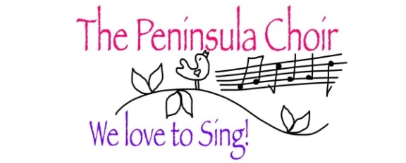

This year we had very little opportunity to do any fundraising, and were looking forward to Seedswap and a pubquiz later in the year. This was to be Donna Moore’s last year hosting Seedswap and we must all give a Resounding Round of Applause to her, because over the years, she and her sisters and helpers have raised the astonishing amount of £3,350 in the most enjoyable way possible. I cannot remember a Seedswap day that it didn’t rain, or wasn’t chilly, yet it was always something to really look forward to. And we had no opportunity to have our last Seedswap at Donna’s, with all the ceremony etc, so instead, we got her a lovely Japanese Cherry, in flower at the time of Seedswap, to thank Donna, and remind her every early Spring of those happy Saturday mornings in March.

We have no idea when anything will return to normal, but our group keeps together in many ways. A Walking Group has been formed, to the benefit of many. Seedswap continued online as a separate Whatsapp group, and it provides many of us with help and insight, as well as glorying in each other’s horticultural successes. The friendships that have been forged throughout the years will endure, I am sure, but when will we be free to Sing Again??

I conclude this report with heartfelt Thank-Yous to our Committee, and Emma.
Our Splendid committee works away in the background, and I thank every one of them for their faithful contribution to the smooth running of our Choir. If anyone would like to join our Committee, please put your name forward. Christine would like to take a break from being Treasurer, so do consider that. She would guide you through her role with ease. Emma, you have given so much to us this year, and spent a lot of time recording parts for the Choir, as we all know. We feel very privileged to have you. In our Portico event we saw you in all your aspects: Musical Director, pianist, singer, leader of the Warm-ups (!) I have been so grateful too, that you have taken over warm-ups with us, as I am not able anymore.

And YOU need a separate paragraph, because YOU are the Choir!! Dear YOU, all of you lovely ladies who love to sing, who turn up each week, who learn your parts, who strive to get it Right, who learn the breath and rhythm of your neighbour, who feel the pulse of the Group, who feel the spaces in between. You who sing closely with your neighbours but hearken to the others, seeking to be in harmony, in time, in sync…sometimes it doesn’t work…ha! ha! Try again… This is beautiful work we do every Tuesday, and take joy in sharing with the world two or three times a year. It’s good work, it’s important for us, and wherever we can share it, we will.

I hope and pray that we may come together again, soon, and make some joyful sounds.

Bee Kupicha
Chair and Choir Leader
22nd September 2020

