10 Years of The Peninsula Choir --- How it all began.
From our first AGM: ‘This Choir came into existence after a brief conversation with Sara Brown about where children of this area could find a good singing experience that would really stretch them and give them something wider than hymns and musicals. She challenged me to think about starting a choir – and so we did!’

The Peninsula Youth Choir.
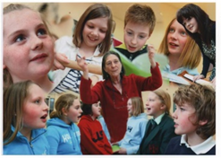
We hired the Hall at Kirkistown Primary for our practices. A photographer from the Chronicle came early on and managed to make our small group look somewhat bigger.
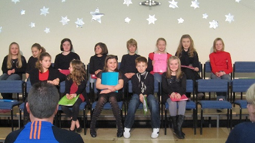
They were a lovely bunch and very enthusiastic, so we were able to do both a Christmas concert and one in June, both of which were well attended, so we had high hopes that our growing Choir would continue into the next year.
Alas, it was not to be! We had decided to relocate to Kircubbin – more central, more children? But in September, only a few returned and no new ones came.
What to do?
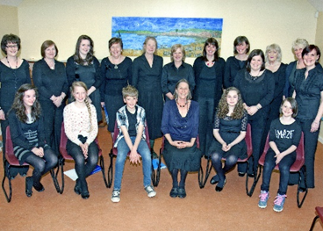
From the Annual Report Sept 2012:

‘We started our year with high hopes for a bigger Youth choir in our new surroundings and with our newly acquired piano but we failed to attract previous members from Cloughey, and no new children arrived! After 3 weeks we were forced to admit that this was not going to work. However, refusing to be beaten, we did a big publicity splurge with a jollier poster and fliers which invited anyone and everyone to Come and Sing for Fun, and we relaunched ourselves as The Peninsula Choir in October. It worked. By Christmas we had 14 members, all female, bar Tommy Brown. (The few men who did join had melted away by Christmas.)
During that first year we also sang at the Christmas lights in Kircubbin, Cloughey and GreyAbbey.
We had 21 members by the end of the year, including Donna and Madge
Our April concert, and don’t we look smart? So just look who’s here
Cheryl, Mary, Lorna, Jessie, Bubsy, Gill, Sharon, Kathleen, Sara, Carolyn (Porter) and Iona Porter
in front, Carol and he Hannah in front, Bee, Sara’s Tommy and Jessie, and Sharon’s Rebecca.
Carol was our pianist at the time, having been roped in to the Youth Choir. They were great youngsters, and we had a good party at Sara’s at the end of the year. The first of many!
Onwards then to 2012-13, when things really started to take off. Only 1 picture from this year, at the Abbacy in June. Imagine, so many of us, so soon, and most still with us.
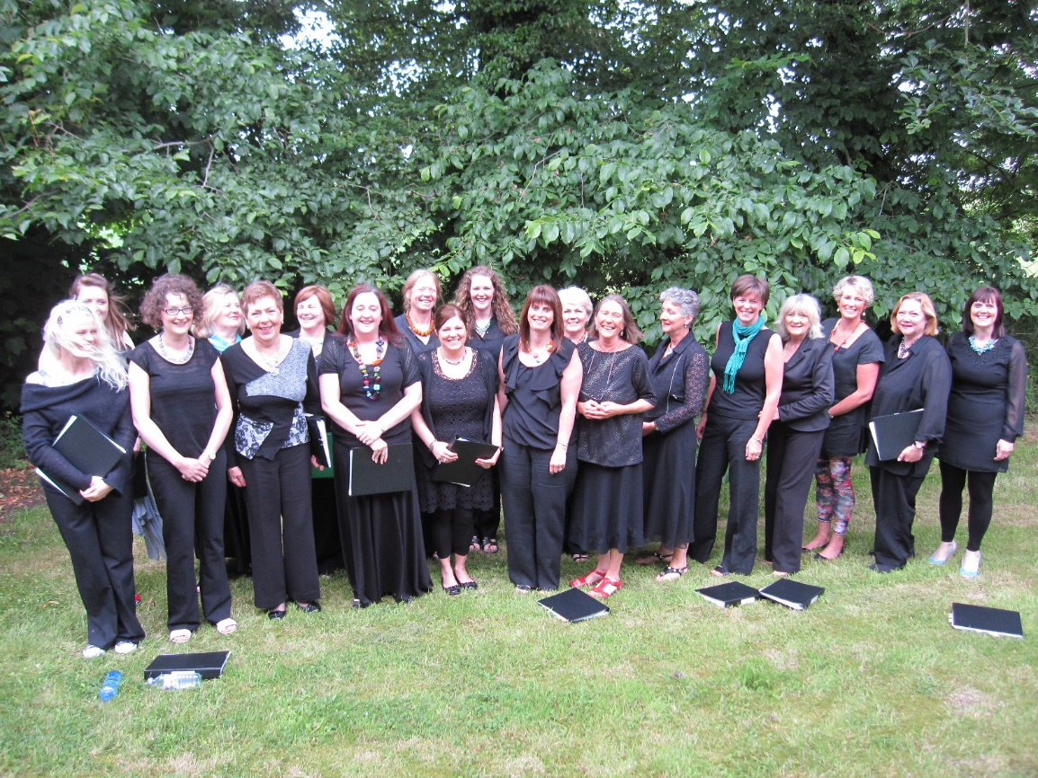

Here now joined by

Christine
Vicky
Pam
Carol Moore
Natalie ?

During this year: Seedswap began. We bought our keyboard (Carol still our pianist, chose the instrument for us). We tried to join up with the Fishermen’s Choir, but although some men did come to Maxwells one evening, only 1 could be persuaded through the door – Gill’s dad!! He’s been a great supporter ever since!
Christine took over Treasurer from Donna. Yes, it’s been That Long….
We sang in Harrisons of GreyAbbey for a fundraiser for Assissi, did the Christmas lights in Portaferry and Kircubbin, and had our own Christmas concert. Over the summer a small group practiced a few songs for Rebekah Sachno’s wedding, at Mike Yeoman’s house, as he was to be the pianist.
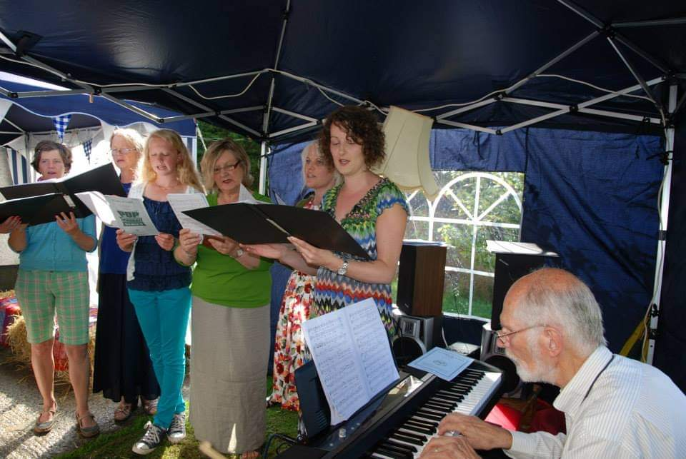
Everyone so colourfully dressed, for a change! Even colour-co-ordinated… it was a very wet day, among those Fields of Gold, and Bubsy had to do some drainage work with a spade. I wish someone could have found that photo.

2013-14
This was the first year we had musicians to help our Midsummer Concert along, held in Kircubbin Presbyterian Church. Didn’t it make a difference to our singing to be accompanied by fiddle and accordian. Who remembers getting the giggles with the ‘microwave ping’ of the Tibetan bell? Here’s Paddy with us for the first time, on drums; on fiddle, Trish Clarke, a local girl, and Fran Byrne, my brother-in-law from Dublin on accordion. It was a wonderful evening. We had worked so hard on some Really difficult songs, especially She Moved Through the Fair and My Lagan Love, and the Choir felt focussed in a new way. Later Paddy and Fran played the evening away at Sara’s house
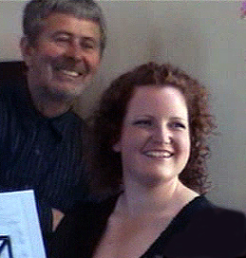
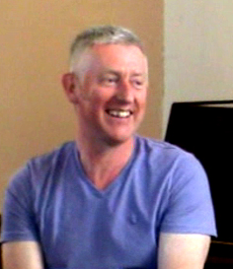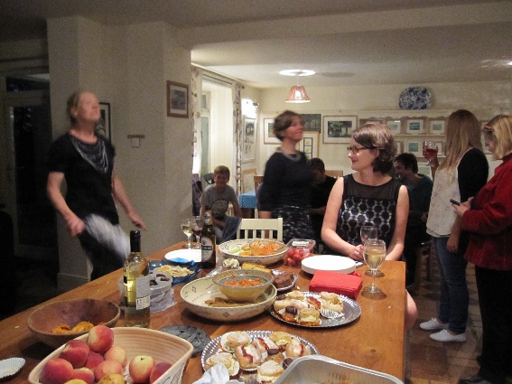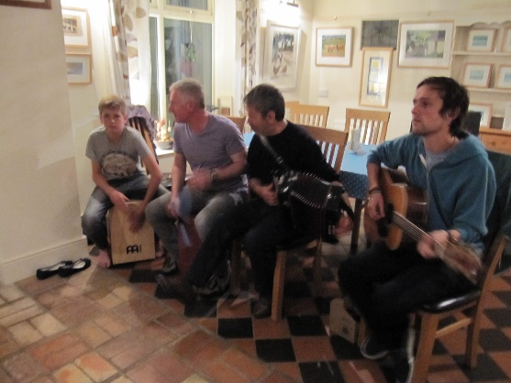
Remember Kate and Bubsy dancing? Such happy memories.

Other activities: Our first visit to Barrhall, Come and Sing both with the Philharmonic, and in St Anne’s Cathedral, Seedswap, our first Pub Quiz in the Saltwater Brig, Mount Stewart – freezing, open air, the amp was missing a cable…oh dear! But a great night in Portaferry Presbyterian as The Choir for the Portaferry Community Carol Service. Wonderful acoustics. 2 parties at Carolyn’s house.
New this year: Deirdre, Kate, Jeanie.

2014-15
During the first term we had a publicity push in the Chronicle, and this year we became 30 strong, from which we’ve never strayed, and the membership has remained largely the same. Amazing!
We were asked to sing at Stormont for the launch of the Carol Ship initiative, and so we did. On a very cold wet November evening , in a hired bus, it was chaotic on arrival, as they weren’t expecting us at the security barrier, or inside, and we all had to be given lanyons. But the actual evening was terrific, the Long Hall packed, good nibbles after the speeches. We sang Panis Angelicus, which raised an eyebrow or two – Latin? Sung in Stormont?? A first!!
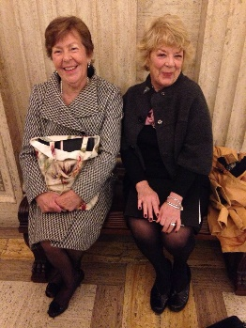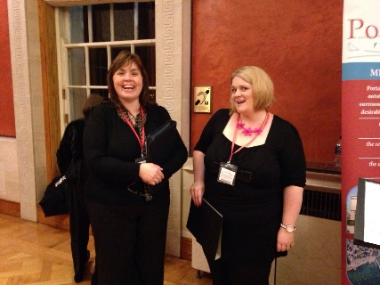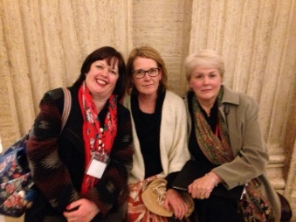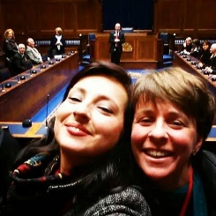

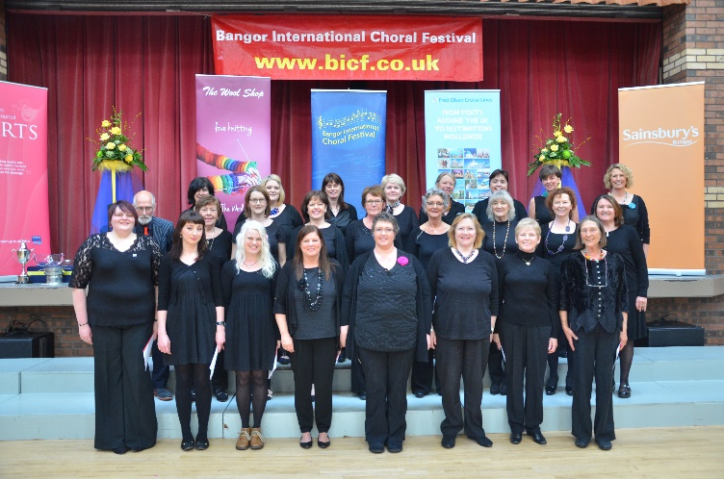
In April we did our first Bangor International Choral Festival. Oh the horror of knowing we were the Only Choir with our music in front of us, and then that really silky-smooth Choir sang The Seal Lullaby Really, Really well. Which was one we were going to sing too! They won the Ladies section, of course, but we did well, for such a young Choir. I was proud, and we all felt we’d learnt a lot from the experience.
New this year are Gemma, Karina, Cathy (and Erin, surely) Millie, Eibhlín, Deborah, Una, Alexandra, Caroline, Carol MacDonald.
We held a packed-out Summer concert in Ballywalter. A great night, with the back door open to the sea, and us singing The Seal Lullaby, as well as The Divine Image, two of my all-time favourites.
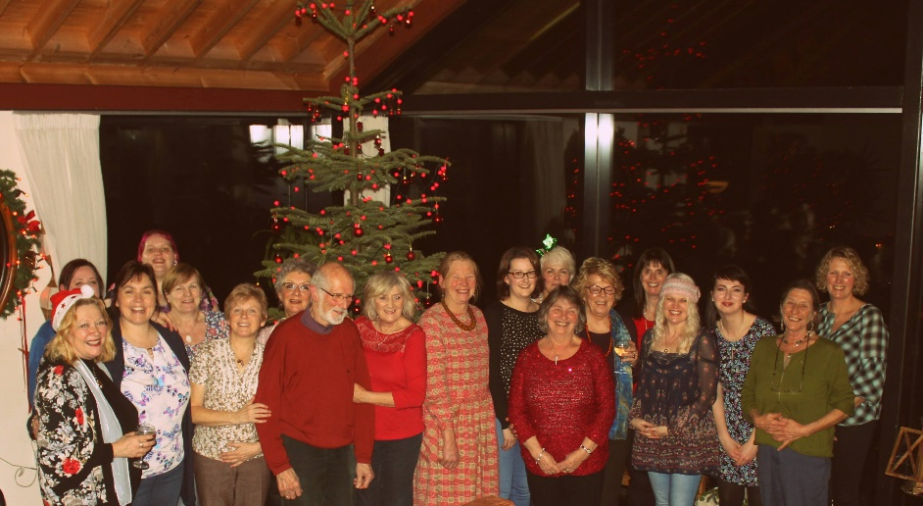
Other activities: Ard Cuan visited for the first time, Come and Sing with the Philharmonic in February, The Gateway Club for Christmas singing, the usual lights-ons, singing on the Carol Ship, Seedswap and the Pub quiz, again at the Brig. Was this the year Christine and others sang The Longest Time for me?? Ulster Hospital, in the foyer and a ward. Not many people in the foyer, but the acoustics are stunning! We sang for ourselves! And Christmas at Karina Wilson’s home in Ballyhalbert. I don’t know why Millie and Kathleen are holding Mike up…..

2015-1016
Emma joined us, as Mike retired due to ill-health. That was a Happy day when she walked through our door.
Summer Concert was themed ‘Folk songs from the British Isles’, held in Cloughey Presbyterian Church. We were joined by Paddy, Ruth Clarke on flute, and an old friend of mine and Emma’s, Astrid King, violin. During our interval Emma and Astrid gave a furioso rendition of one of Bartok’s Romanian Dances. Electrifying!!
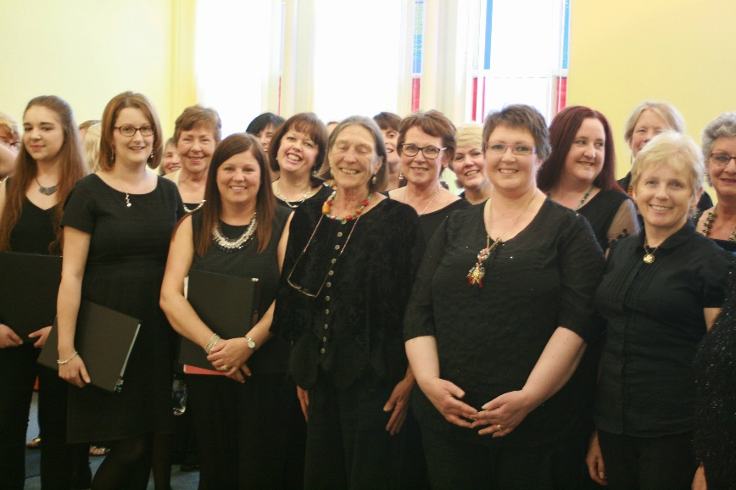
This was before the service at Carrowdore Presbyterian Church. We look really professional here!
A representative from Donaghadee Male Voice Choir approached me and asked if we would be interested in joining up in some way. What an honour that would be. But alas, nothing has come of this. Yet.

This was the year Sara created our logo.
Other Activities: Gateway Club, Cross-Community Carol Service, COI Portaferry, Ard Cuan and Barrhall, Kircubbin Lights, Carol Ship, Come and Sing with the Philharmonic, Seedswap, Pub Quiz, Christine’s son’s wedding.

2016-17 We’re 7 years old!
Seven years, a magic number signifying the completion of a phase of life, and we strengthened our determination to improve by attending a workshop in Portico in March entitled The Tenebrae Effect. We were lead through an amazing experience of singing in a new contemplative way with each other, through being conscious of our breathing together, feeling a one-ness with the group, which on that morning was a collection of unknown individuals from many parts. It was beautiful. We ended the session, in a tight group, eyes shut, singing what we had learned that morning, in total one-ness, listening, and breathing together. We who were there brought that back to Choir, and we’ve never looked back. A very profound experience from which we have reaped huge benefits.
Paddy was very keen for us to record some of our music, so ‘The Running Wave’ was recorded in Cloughey Presbyterian Church in late Spring. What an exercise in Attention, Quietness, Precision, etc. Rather an ordeal, but ultimately worth it. Our first CD! with cover design by Sara.
Our final gig was the Carrowdore wedding. We sang for an hour before sitting down for half an hour, waiting for the Bride. She was led in by bagpipes, which we had to sing with/over!! A very tedious day, followed by a lovely meal and chat at Eden Pottery.
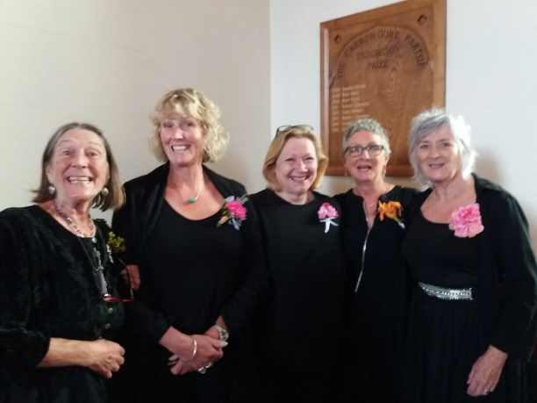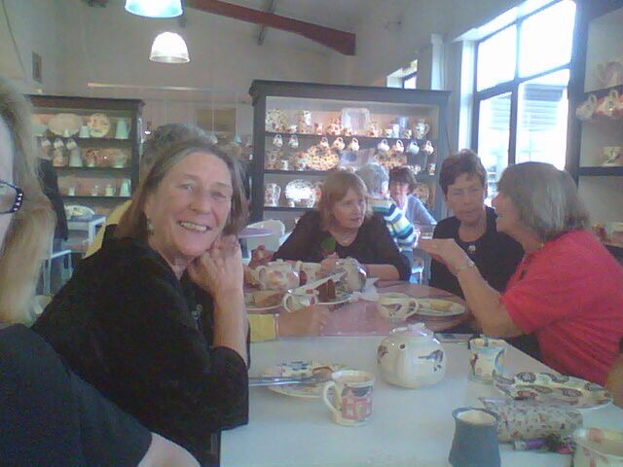
We are Relentlessly Cheerful during this lengthy Ceremony, but happy now after Food!
Other activities: Summer Concert again in Cloughey, with dear Martin Donnelly singing his songs during our interval. Cally Loves the Sea anyone????
Christmas pageant in Greyabbey. Who can forget murdering The Angel Gabriel in the Abbey ruins? Another lesson to be learnt about open air singing.
Gateway Club. Christmas at Karina’s again. Kircubbin lights. Pub quiz. Carol ship. Ulster hospital. Denise joined this year, as did Lorraine, and Bernarda and, I think Noa.

2017-18
The last year for Jessie, one of our Founder Members, but she still contributed a year later, when I asked her to make a cover for the amp. Thanks Jessie. We still miss you.

We went a bit Pop! for our Summer concert, with songs from 60’s to 80’s, held in St Patrick’s Community Centre, Portaferry. This year Paddy’s son, Theo, helped with percussion as we were doing ‘Africa’, and for the first time with Clive Wills on guitar. Victoria danced for us, an astonishing exhibition of athleticism and grace, and Erin sang for us, beautifully.
When I first asked Erin to sing a solo it was like listening to a kitten in a shoebox. How far she has come!!

Other activities: Carol Ship, Lights-on, Kirkubbin, Care Homes, Christmas community service in Cloughey Presbyterian Church, Ulster hospital, which was a bit strange in the new wing, which is all empty corridors and single rooms, and - well - no-one to sing to! At least last year we sang to a captive audience in the Care of the Elderly wards, and Carolyn’s ward.

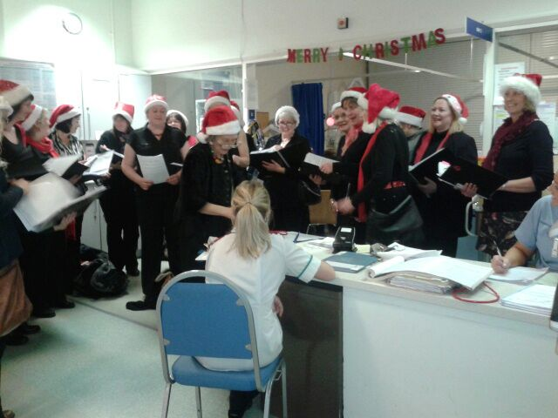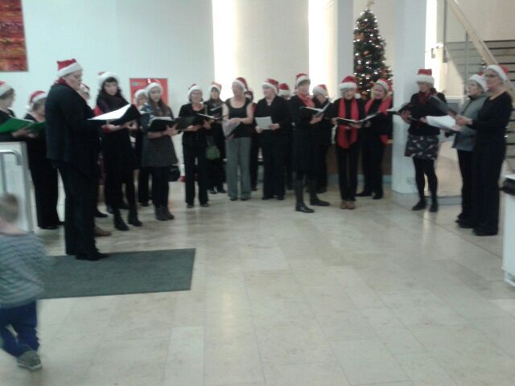
Ulster hospital. Carolyn’s ward. The foyer.
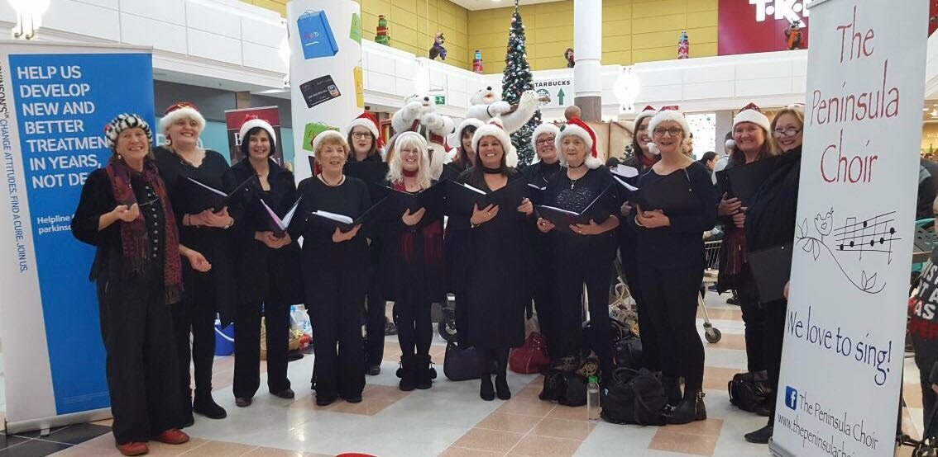
A fund-raiser for Parkinson’s Disease in Ard Shopping Centre. Sara had got us 2 ‘penguins’ to display our name and logo.

We sang a cappella for 2 half-hour slots, and attracted a crowd of quiet listeners. It was rather beautiful.

Other activities: Carol Ship, Kircubbin Lights, Christmas event in Cloughey Presbyterian Church, Ulster hospital, Seedswap.

2018 – 19
The year of our Triumph at Bangor International Choral Festival. Runner-up in our group, with the 2nd highest score of the competition!! So proud!

Here’s that photo again:
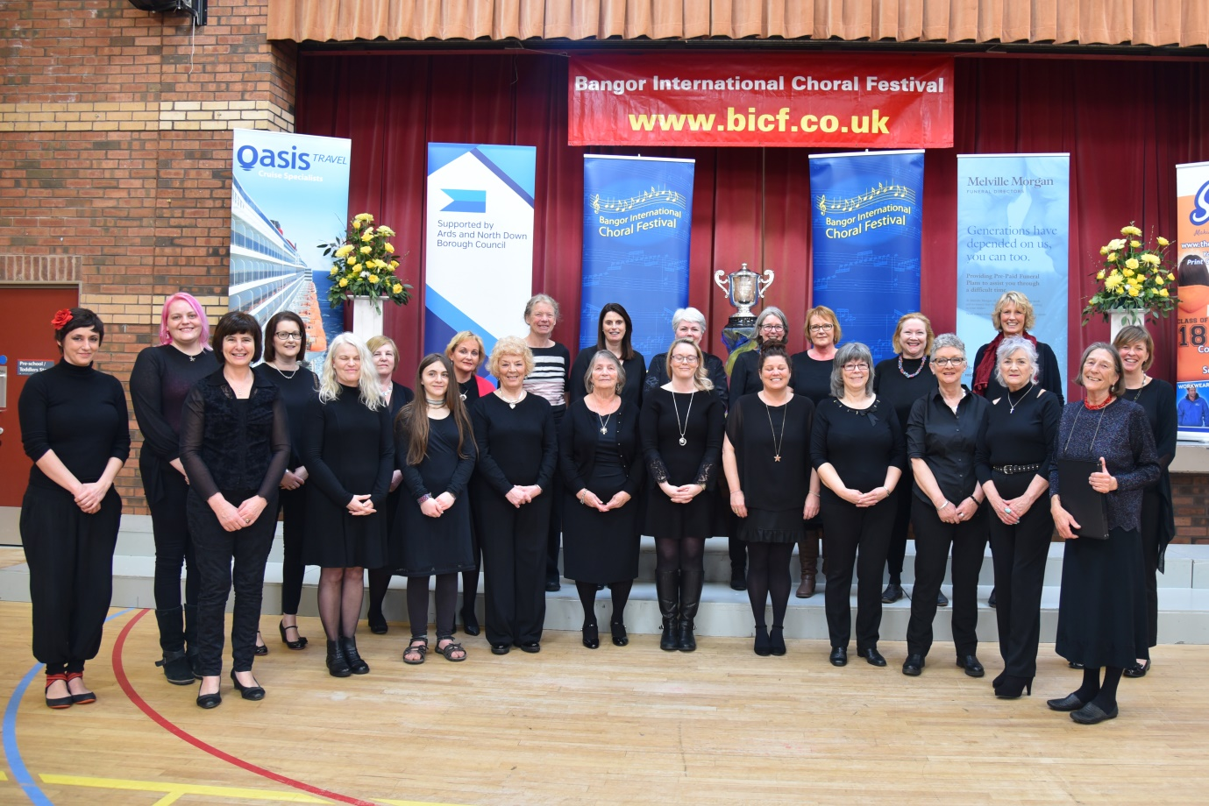

Thank goodness Denise was in the audience and took a video, and that she and Lorraine were so noisy in their applause.
We said goodbye to Erin at the end of this year. What an asset she has proved to be, singing solos effortlessly, and playing flute for us. This year also, we recorded our Christmas CD, and had that wonderful concert in Portico with Steven Irwin and the pupils from Kirkistown Primary. Lucky children to have Steven for their musical education, and it really showed how much fun they were having. A wonderful evening, also joined by Jamie Brown, Eimear Roddy and Callum Burgess, oh And Santa. Emma sang and made me cry.
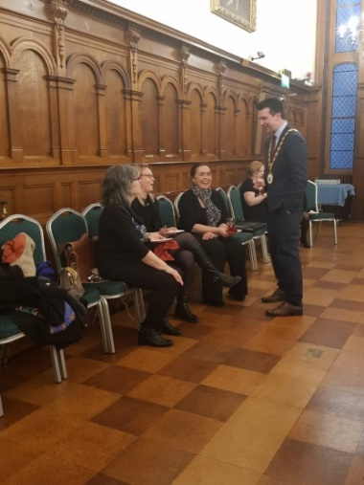
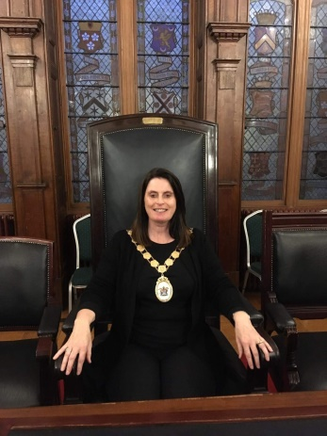
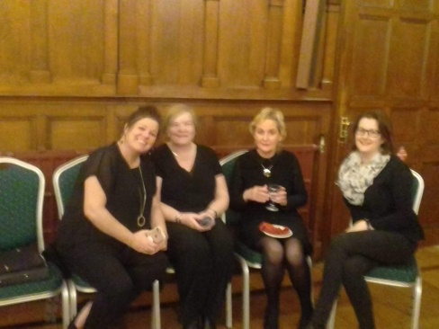

An evening with the Mayor In Bangor Castle. Gill looks quite at home here!

Other activities: Singing for Ard Cuan and Barrhall, Portaferry Christmas Market, Kircubbin Lights, an invitation to sing for Millisle and Ballycopeland evening service. (Carol played. We couldn’t hear the Choir, or the piano; all speakers were trained on the congregation. Very strange!) Seedswap, of course. May Portaferry Saturday Market. No Summer concert, due to European football finals! And we made our Christmas CD, Thank Goodness!
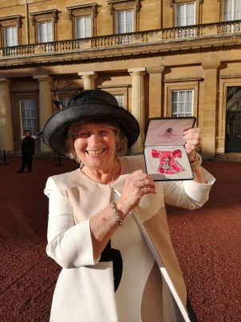
New members: Amanda, Alison, Mary and Sal.

Jeanie got an MBE for her years of dedication
to the Kidney Transplant service.

Here she is at Buckingham Palace.

2019 - 2020

The Big highlight of the year was our Smash Hit concert, ‘Songs from the Movies’ with Steven Irwin and Cheryl duetting ‘All I want is You’. Brilliant! And who will forget ‘Don’t You Weep, You Little Baby’, and Carolyn bravely soloing, which she perfected in Portaferry?
The beautiful tables in Millisle and Ballycopeland’s hall.
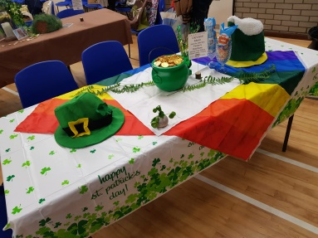
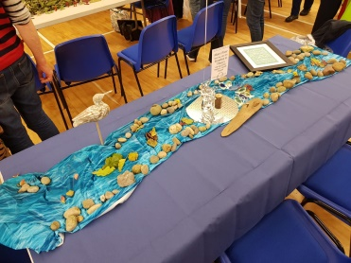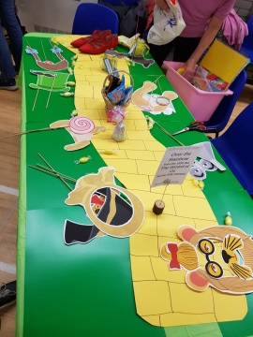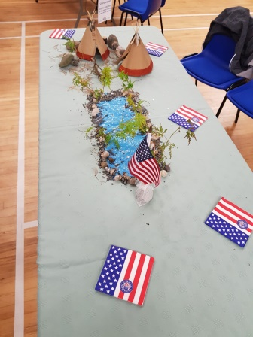

The other Highlight was that terrific Christmas event in Portico with the other two choirs, Amici and Donaghadee Ladies. We all had such a different repertoire, and it felt really good to bring together so many diverse people under one roof.

A lovely meal was had in December, in Katch 27. Lots of song and laughter.

Our last gig in Portaferry was the fundraiser for the Church of Ireland. And the first time we had our own microphones and mixing desk. Thank goodness Gill Withers was able to get it all to work!!

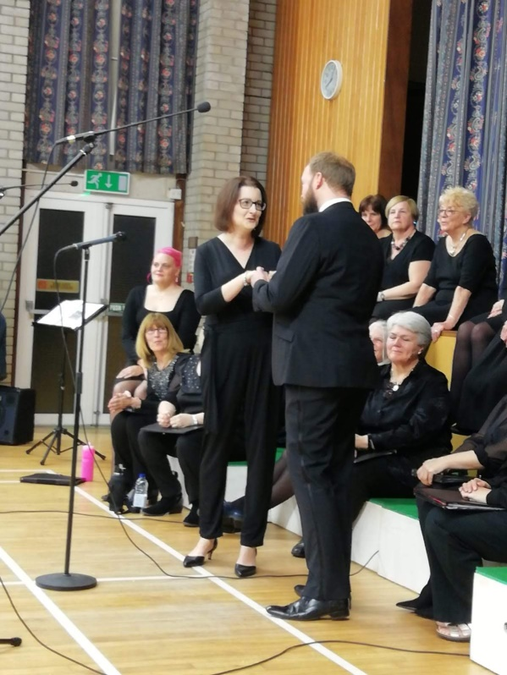

This photo was from Millisle.

For our Portaferry concert Deirdre
bought us these joyful things to wear.
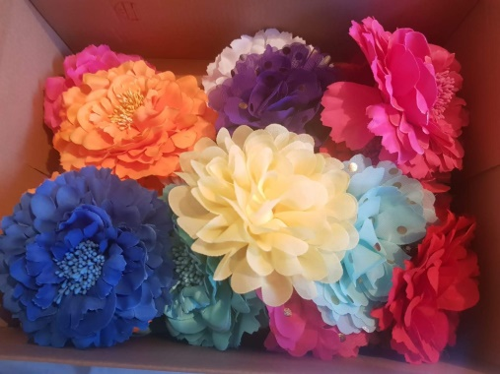

That last concert was delivered with such confidence and tightness, that many remarked on it. And no wonder! We were so well rehearsed, and we absolutely loved all the pieces.

Ah! So much was going for us. We considered entering the Derry Festival the following year and made plans for an evening of ‘Songs from the 60’s’, but alas, we have been overtaken by events. Sadly, Seedswap was cancelled and this was to be Donna’s last year, so doubly sad. We have given her a Japanese cherry which will flower in March, reminding her of all those happy mornings surrounded by our plants, and the food and craic.

Other activities: Kircubbin Lights, Barrhall and Ard Cuan.
New member: Jane McCourt, who came to me at Portico where she was singing with Amici, and said: I Have to join your choir! Well you did, and it’s good to have you.

*************************************************

My Dear friends,
I hope this will fill you with happy memories of all the wonderful times together, and with pride for what we have achieved together. We will, of course, be together again, and when we do it will be the start of the next chapter of our work. I look forward with hope.
Bee xx

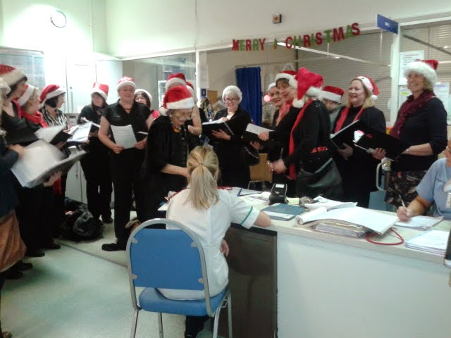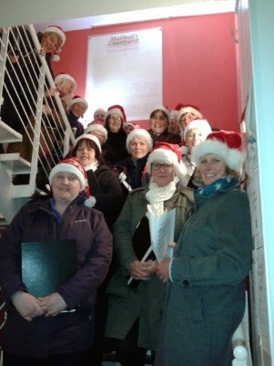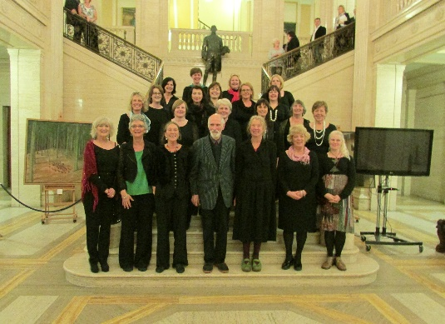
Ulster Hospital, 2014 Heading off to Switch-on Carol Ship launch, Stormont 2014
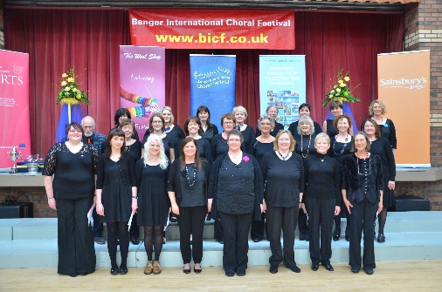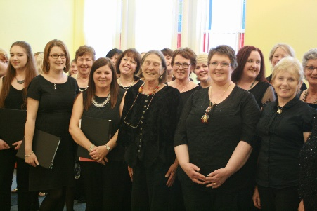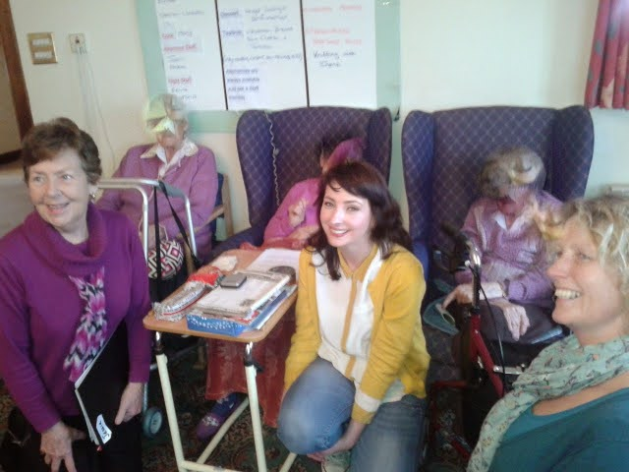
Ist Choral Festival, 2015 Carrowdore Presbyterian 2015 Care Homes at Christmas.
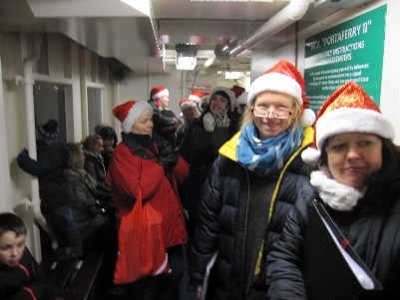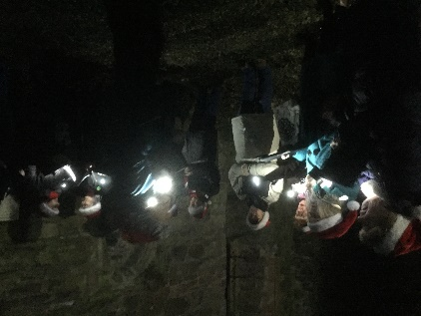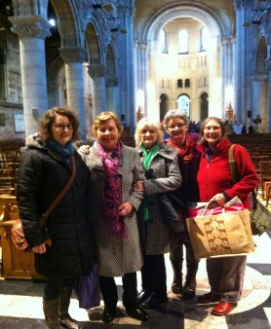
Carol Ship, we did this for 4 years Greyabbey….! December 2016 St Anne’s. Come and Sing,
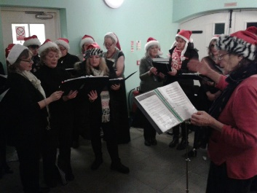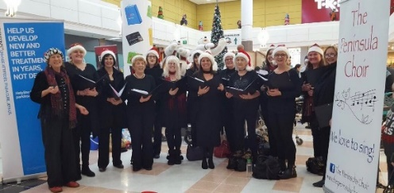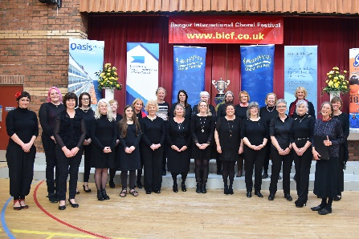
Maxwells, every year. Ards Shopping Centre 2018 Our moment of Great Triumph!! 2019
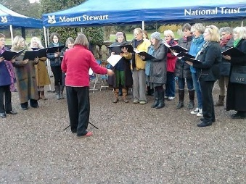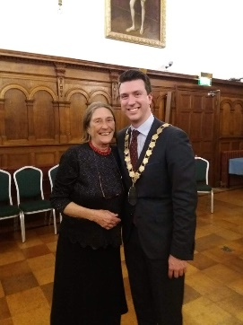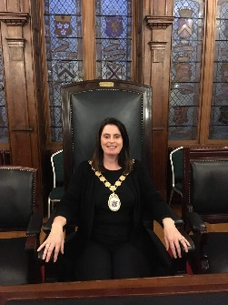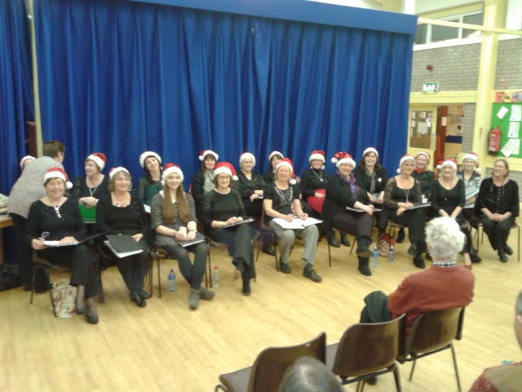
Mountstewart. Brrr. 2013 Mayor’s reception, 2019. Gateway 2014
Weddings
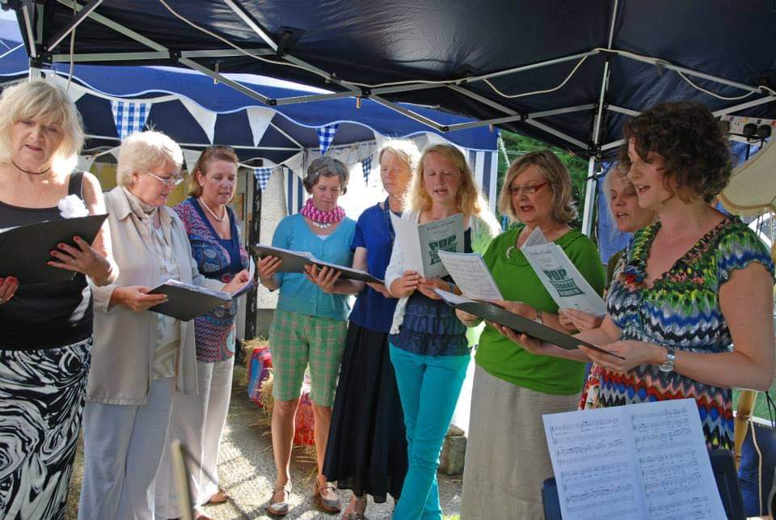
Rebekah and Paul, August 2013 at Carolyn and Greg’s, Kearney.

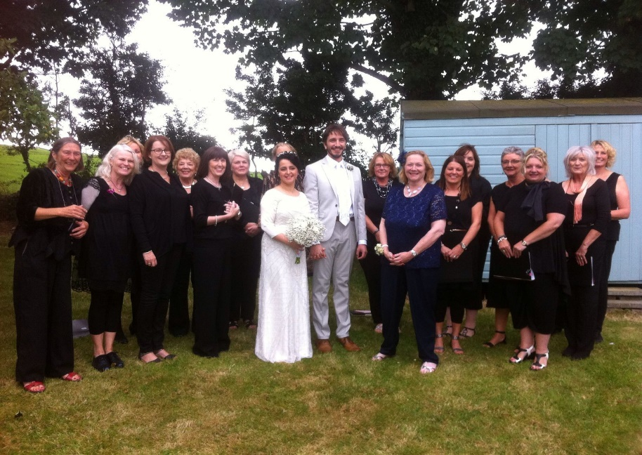

Ryan and Somayéh Jendoubi Aug.2016, Christine’s garden, Portaferry.

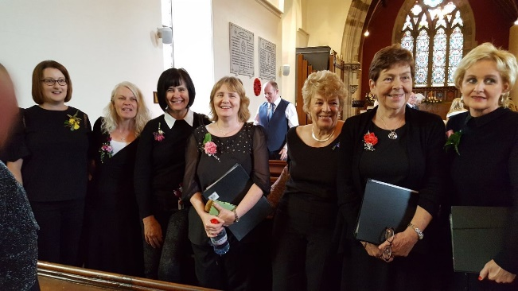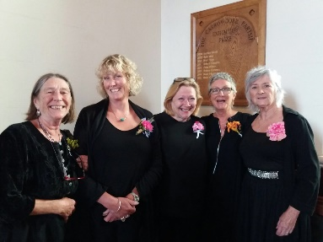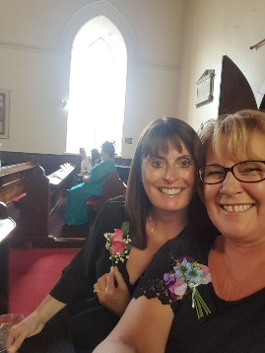

Carrowdore, August 2018…..a long tedious day! But we were relentlessly cheerful!!!
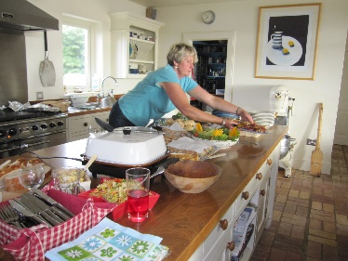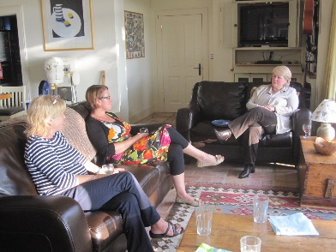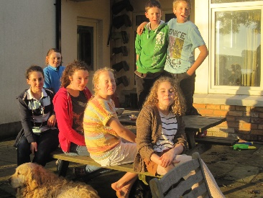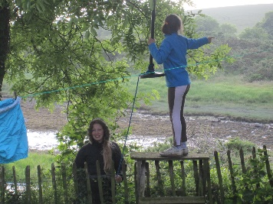
Our very first end of year party 2012
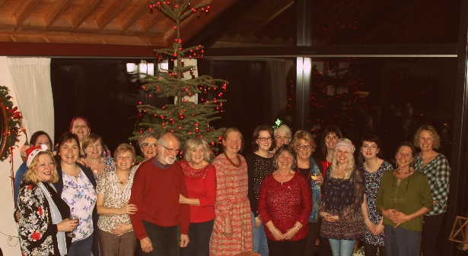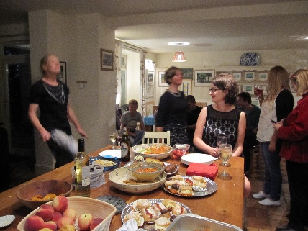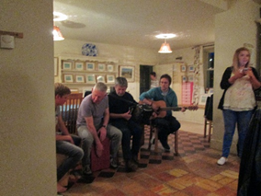
Christmas at Karina’s 2014 June 2014. Kate and Bubsy dance to Paddy, Fran Tommy +? 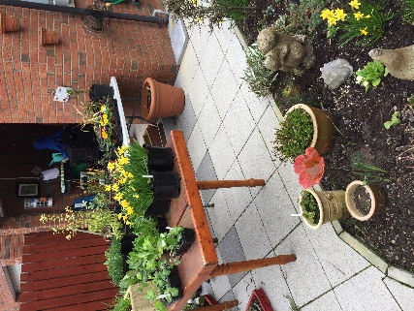 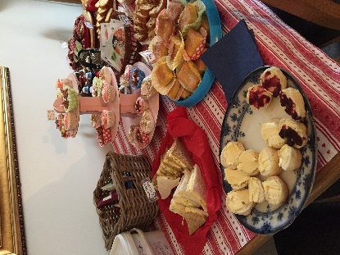 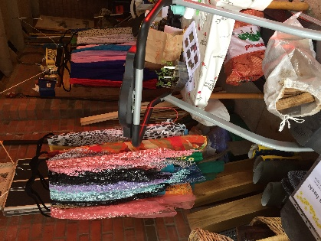 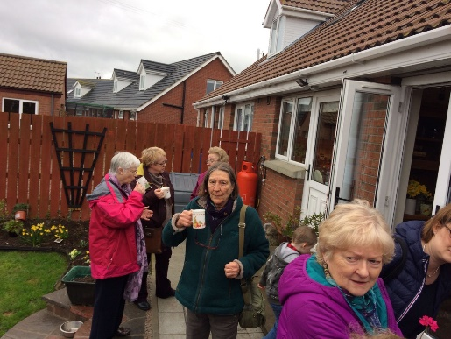
Seedswap, 2013 onwards
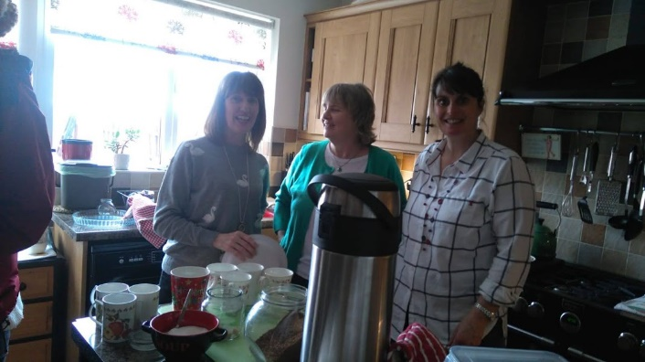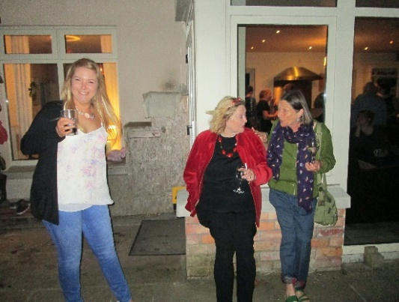
Seedswap’s Kitchen Squad June 2016
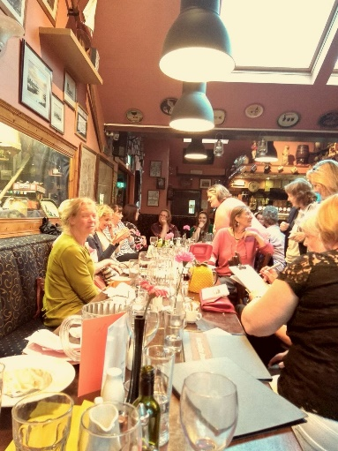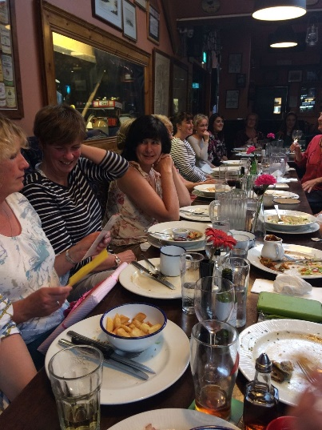
Saltwater Brig Wildfowler 2019 Eden Pottery post-wedding Big Feed

